27.6: a) The smallest possible acceleration is zero, when the motion is parallel to the magnetic field. The greatest acceleration is when the velocity and magnetic field are at right angles:
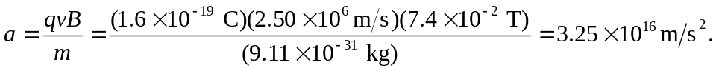
b) If

